Prelimenary Results

L4_SP:L23_PC Neuron models properties:
"number_of_convergent_neuron_std":3.3,
“connection_probability":0.35000000000000003,
"number_of_divergent_neuron_std":9.4,
"total_synapse_count":53367,
"mean_number_of_synapse_per_connection":2.3,
"common_neighbor_bias":2.1,
"number_of_convergent_neuron_mean":1.7,
"number_of_synapse_per_connection_std":0.71,
"number_of_divergent_neuron_mean":8.8

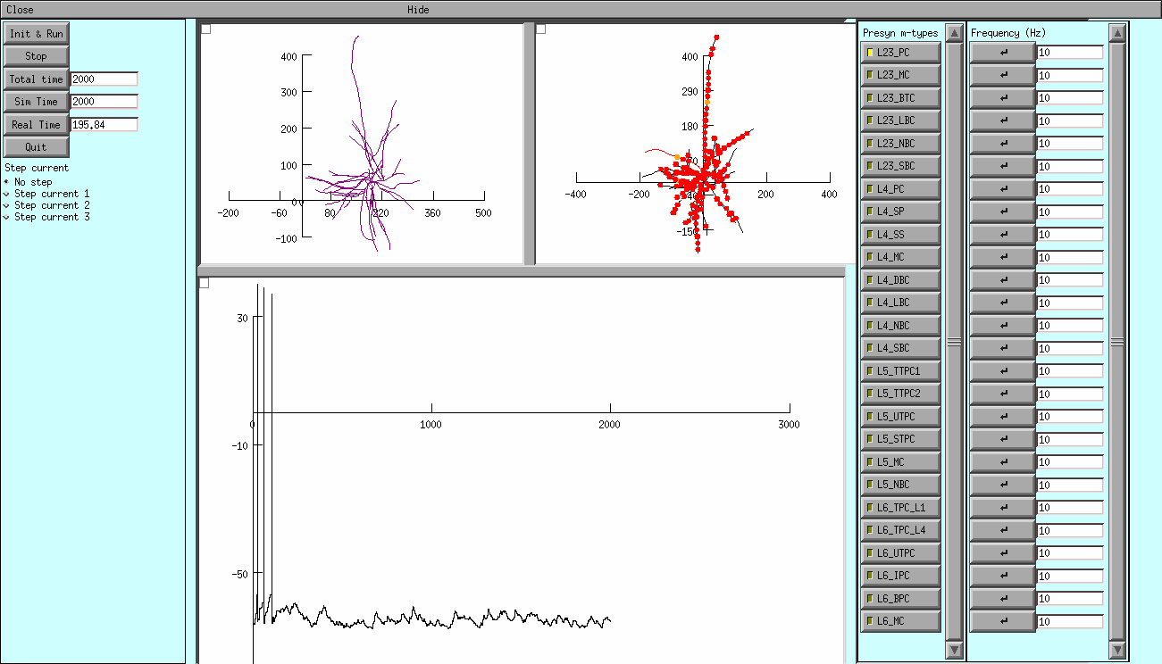
L4_SP:L23_PC for duration 2000ms @ 10Hz
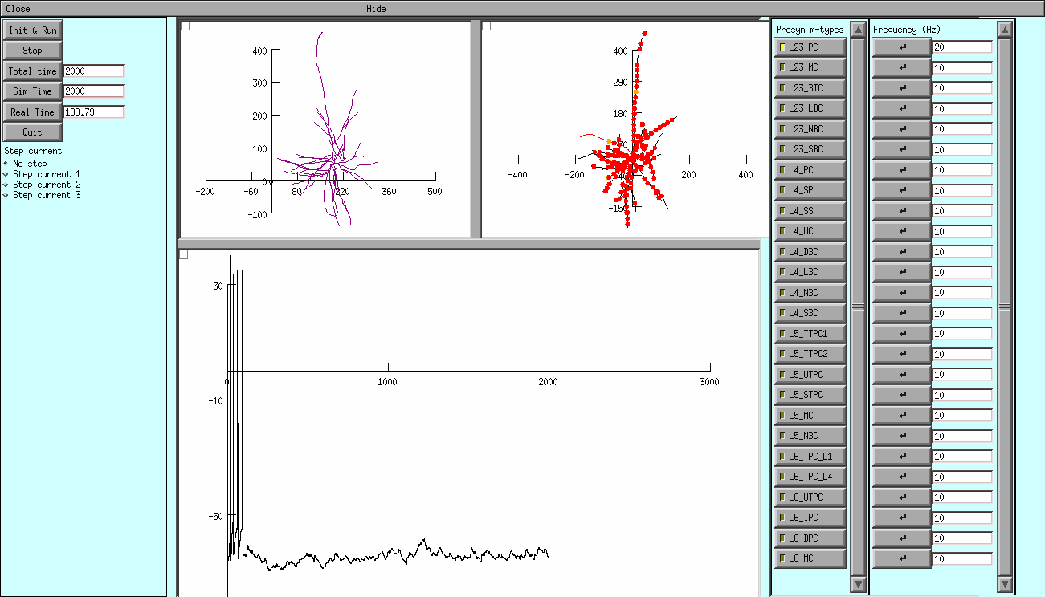
L4_SP:L23_PC for duration 2000ms @ 20Hz

- The graph represents the membrane voltage recorded in the soma. Units are ms (x-axis) and mV (y-axis). Every presynaptic cell will be represented by a Poisson Spike Train and the default firing rate is 10Hz; the two other parts have a representation of the cells morphology.
- The sections in the first morphology change colour depending on their membrane voltage during the simulation. When synaptic input is presenr, the second morphology will show the location of the activated synapses.
- The neuron can be stimulaed in two ways:
Step currents can be selected from the first tab.
Synaptic inputs can be enabled by choosing from the list of presynaptic m-types. When a certain m-type is selected, all the synapses that cells from the specified m-type make on the stimulated cell (in the neocortical microcircuit model) will become active.

